**上机实验7**

**学号**：202030310091 **姓名**：张焕煜 **班级**：电自2005

**一 程序代码：**

#include<iostream>

using namespace std;

class Complex {

double real;

double imag;

public:

Complex(double r = 0, double i = 0)

{

real = r; imag = i;

}

void print();

friend Complex operator+(Complex co1, Complex co2);

};

Complex operator+(Complex co1, Complex co2)

{

Complex temp;

temp.real = (co1.real * co2.real)-(co1.imag*co2.imag);

temp.imag =( co1.real * co2.imag)+(co1.imag* co1.real);

return temp;

}

void Complex::print()

{

cout << "total real=" << real << " " << " total imag=" << imag << endl;

}

int main()

{

Complex com1(1.1, 2.2), com2(3.3, 4.4), total1;

total1 = com1 + com2;

total1.print();

return 0;

}

**二 程序结果：**

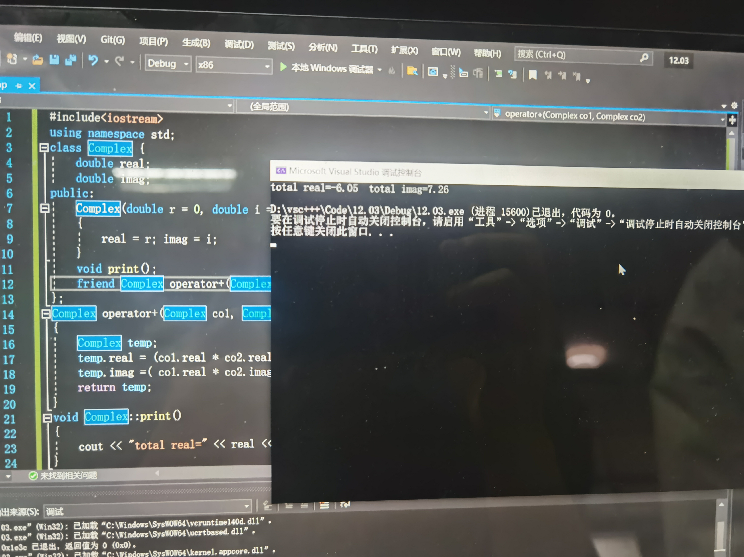

**三 感想心得:**

经过前面的铺垫，和看课本上的代码，慢慢理解了许多知识点，本次实验报告不算很难。